Biology 11 Safety Poster

Consider the photocopy provided

For the Safety Symbols do the following (4 marks total)
- Choose the top 5 safety symbols that would be used in biology (1 mark).
- Choose the bottom 2 safety symbols that would NOT be used in biology (1 mark).
- For all 7 symbols chosen you need to provide a rationale for why they would or would not be used in a biology classroom – write this on a piece of paper to include with your poster (1 mark).
- Draw your own symbol for 1 of your top 5 and include it on your poster along with the symbol’s meaning and rationale as to why it can be used in biology 11 (1 mark).

For the WHMIS Symbols do the following (4 marks total)
- Choose the top 5 WHMIS symbols that would be used in biology (1 mark).
- Choose the bottom 2 WHMIS symbols that would NOT be used in biology (1 mark).
- For all 7 symbols chosen you need to provide a rationale for why they would or would not be used in a biology classroom – write this on a piece of paper to include with your poster (1 mark).
- Draw your own symbol for 1 of your top 5 and include it on your poster along with the symbol’s meaning and rationale as to why it can be used in biology 11 (1 mark).

For the Safety Rules and Procedures do the following (4 marks total)
- Choose the top 2 Safety Rules and Procedures that would be used in biology (1 mark)
- Choose the bottom 2 Safety Rules and Procedures that would NOT be used in biology (1 mark).
- For all 4 Safety Rules and Procedures chosen you need to provide a rationale for why they would or would not be used in a biology classroom – write this on a piece of paper to include with your poster (1 mark).
- Draw your own symbol or write a paragraph for 1 of your top 2 and include it on your poster along with a rationale as to why it can be used in biology 11 (1 mark).

Total Mark for the Poster and Assignment: _______________/22 Marks

Make sure to look at the rubric on the back of the page
Additionally your poster will be marked using the rubric below:
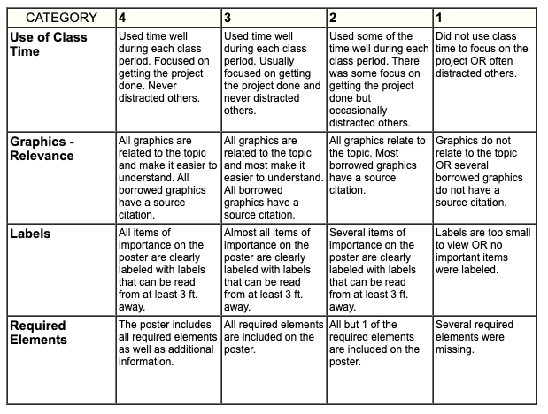
/2
/2
/4
/2

