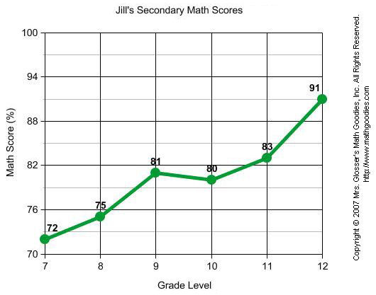

Can we interpolate or extrapolate the graph above? Why or why not?

What is her highest mark and why?

What happened between grade 8 and 9 to improve her mark?

