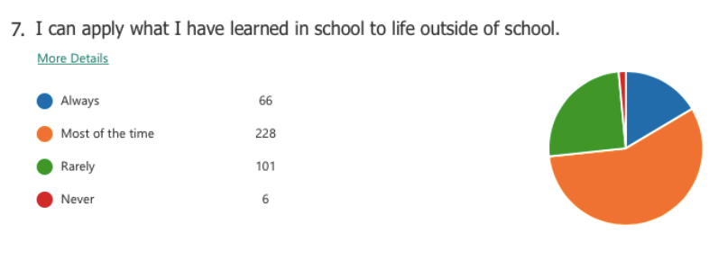

401 students were surveyed at DCSS-SP

- How many students answered always to the question above?
- What percentage said always?
- How many students answered most of the time to the question above?
- What percentage said most of the time?
- How many students answered rarely to the question above?
- What percentage said rarely?
- How many students answered never to the question above?
- What percentage said never?
- What are some reasons for this distribution of votes (why does the graph look the way it does)?

