Dawson Creek is located in The Boreal Plains Ecozone. It is part of the flat Interior Plains of Canada, a northern extension of the Great Plains of North America. The subdued relief consists of lowlying valleys and plains stretching across the mid portions of Manitoba and Saskatchewan, and continuing through almost two thirds of Alberta, including the South Peace. The majority of the surface waters are part of three watersheds: those of the Saskatchewan River, the Beaver River, and Peace, Athabasca, and Slave rivers’ watershed.
The ecozone has traditionally been viewed by some as the next untapped resource frontier.
The Peace Lowland ecoregion is characterized by a unique climate, marked by warmer summers than the surrounding areas. The mean annual temperature is 0.5°C. The mean summer temperature is 15°C and the mean winter temperature is -14°C. The mean annual precipitation ranges from 350–600 mm.
Hours of Bright Sunshine Per Month (30 Year Average)
 | Jan | Feb | Mar | Apr | May | June | July | Aug | Sept | Oct | Nov | Dec
Hrs | 75.9 | 112.9 | 168 | 235.5 | 280 | 296 | 310 | 273.5 | 170 | 144.5 | 85 | 62
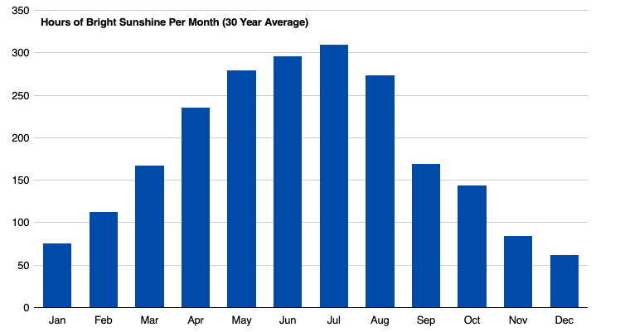

- What month has the least amount of sunshine?

- Which months have greater than (<) 270 hours of sunshine?

- Does your answer for #2 seem reasonable? Explain.

Average Temperatures
 | High | Low
January | -7.2 | -19.0
February | -3.9 | -16.5
March | 0.9 | -10.9
April | 10 | -3.1
May | 16.4 | 2.1
June | 20.1 | 6.9
July | 22.2 | 8.9
August | 21.5 | 7.2
September | 16.2 | 3.3
October | 9.0 | -2.4
November | -1.5 | -12.2
December | -5.3 | -16.8

- What patterns can you identify in the “Average Temperature” table above? Do these patterns seem reasonable?

- What patterns can you identify in the “Extremes” table below? Do these patterns seem reasonable?

Extremes
 | Date | Value
Maximum Temperature | 22-Jul-06 | 35.0°C
Minimum Temperature | 29-Dec-92 | -49.2°C
Rainfall | 11-Jun-90 | 75.2 mm
Snowfall | 17-Aug-73 | 35.3 cm
Wind speed | 02-Nov-78 | 87.0 km/h
Wind-chill | 15-Jan-71 | -57.0°C
Humidex | 31-Jul-71 | 39.2
Snow Depth | 06-Feb-82 | 86.0 cm

Source: https://www.dawsoncreek.ca/business-community-profile/community-profile-climate/

