Notes obtained from Ducksters.com – Predicting the Weather

Highs and Lows
Knowing areas of high and low air pressure is important to predicting the weather because differences in air pressure causes wind to form.
High pressure system - A high pressure system generally means good weather because it attracts cool and dry air. On a weather map a high pressure system is shown by a blue H.
Low pressure system - A low pressure system generally means rainy or cloudy weather. This is because low pressure systems generally attract warm and moist air. On a weather map a low pressure system is shown by a red L.
Weather Fronts
The boundary between high and low pressure systems is called a weather front. It is where these two different masses of air meet that most storms form.
- Cold Front - A front where a cold air mass is replacing a warm air mass. When a cold front passes through, the temperature will drop. Cold fronts can cause a narrow line of storms and can cause the weather to change rapidly.
- Warm Front - A front where a warm air mass is replacing a cold air mass. Warm fronts tend to move more slowly than cold fronts. They often bring rain and clouds.
- Stationary Front - A stationary front is a front that stays in one place for a long period of time. Stationary fronts can bring long periods of rain.
- Occluded Front - An occluded front occurs when a cold air mass takes over a warm air mass.
- Dry line - A dry line is a boundary separating a dry air mass from a warm air mass. There can be large differences between the temperature and dew point on each side of the dry line.
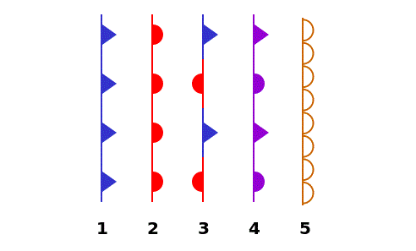
Weather front symbols
1. cold front 2. warm front. 3. stationary front. 4. occluded front. 5. dry line
Meteorological Technology
A lot of technology goes into measuring and predicting the weather. Some of the tools meteorologists use are described below.
- Doppler radar - Doppler radar is a special kind of radar that can determine the rate of precipitation (rain, hail, snow) as well as wind speed and direction. This can help meteorologists in providing severe storm warnings.
- Satellites - Satellites can be used to see cloud formations over large areas of the Earth.
- Rain gauge - A rain gauge is tool used to measure the amount of rainfall.
- Anemometer - An anemometer measures the speed of the wind.
- Barometer - A barometer measures the air pressure and whether it is rising or falling.
- Computer Models - Weather forecasting uses computers to model the weather using the various measurements and information gathered
Part 1: Fill in the Blanks (7 marks)

- A _____________ measures air pressure.

- When the weather is good there is typically a ____________ pressure system.

- A device used to measure temperature is called a _______________________.

- Cold air replaces warm air in a _____________ front.

- Humidity is measured using a ___________________.

- A __________ pressure system leads to stormy weather.

- A _________ front occurs when warm air replaces cold air in an area leading to rain.

Word list
- thermometer
- warm
- barometer
- cold
- hygrometer
- low
- high

Part 2: Draw the weather front symbols (all 5) and describe why they are used (10 marks).

Weather Front Symbol | Description
Part 3: Short Answer:

Using the information provided on the previous pages, write a paragraph (4 to 6 sentences) describing how meteorologist predict the weather (4 marks).

____________________________________________________________________________________________________________________________________________________________________________________________________________________________________________________________________________________________________________________________________________________________________________________________________________________________________________________________________________________________________________________________________________________________________________________________________________________________________________________________________________________________________________________________________________________________________________________________________________________________________________
________________________________________________________________________________________________________________________________________________________________________________________________________________________________________

