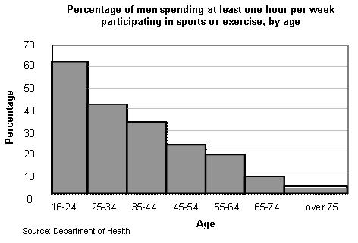

- Which group is the most active and why do you think that?

- Which group is the least active and why do you think that?

- What are the limitations of this graph?

