How to create a graph in Excel:

- Open Excel (below is what it looks like)

- Open a blank workbook
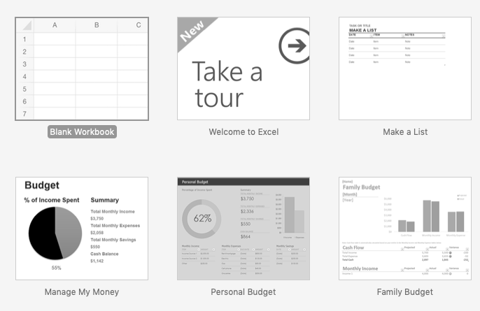

- Save to you home folder (the example below says desktop DO NOT SAVE TO DESKTOP)
(“your name” survey result.xlsx)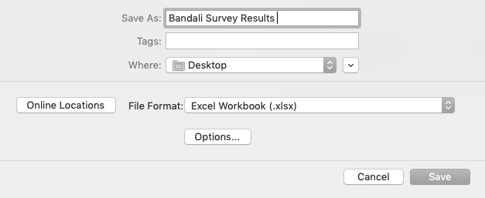

- In A1 Write your question
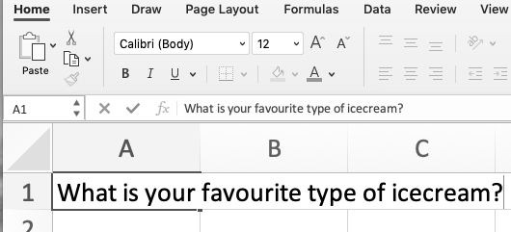

- In A2 your category
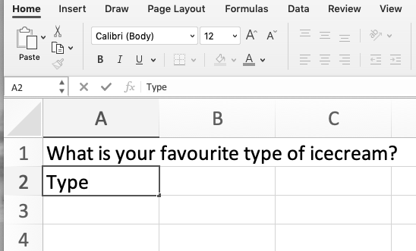

- In B2 votes
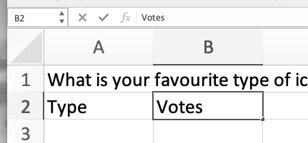

- Write your category names under the category heading
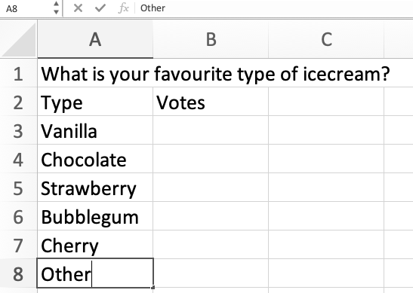

- Fill in the votes for each category
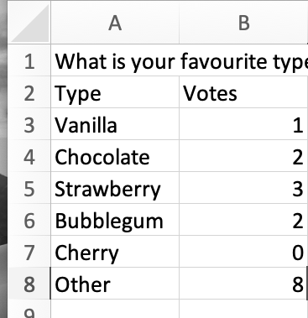

- Highlight cells to graph
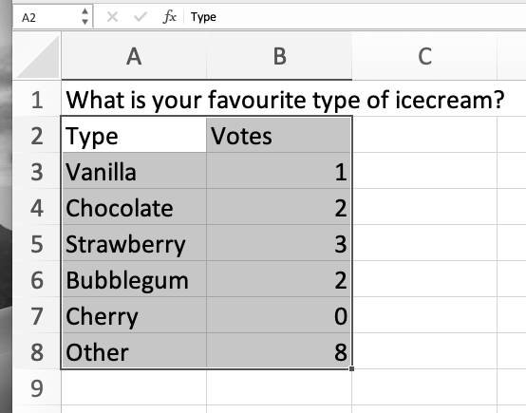

- Insert recommended charts
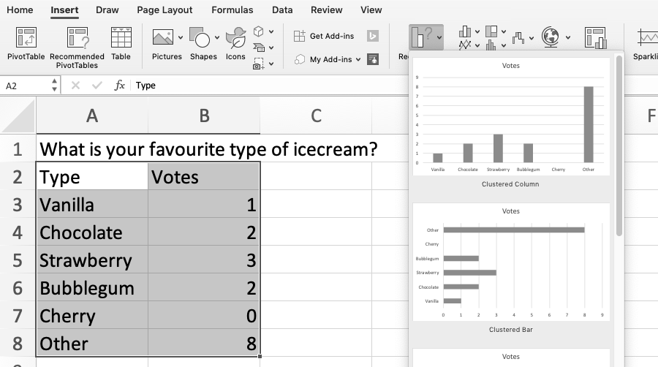
- Choose a graph type (state why you chose that type of graph in one of the cells of the excel spread sheet)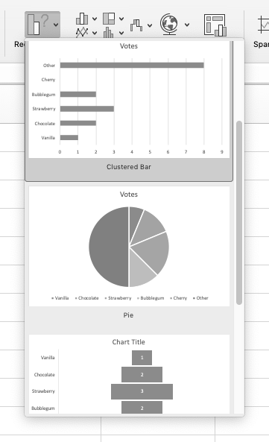

- Double click title and change it to your question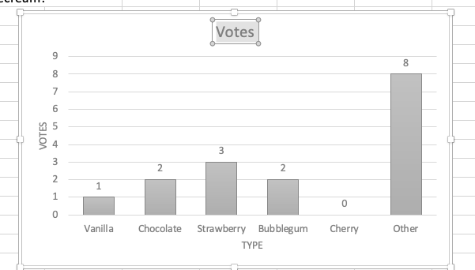

- Click on quick layout under Chart Design

- Change the layout to #8
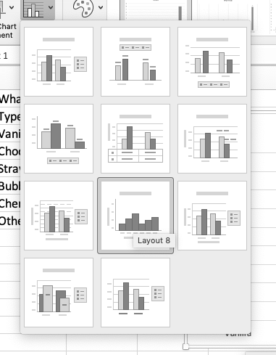

- Change the layout of your graph back to a bar graph
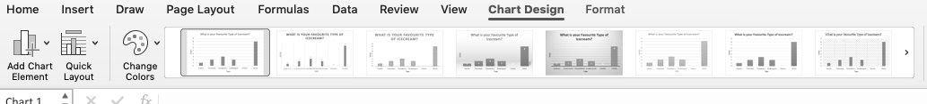
- Change x axis title with your category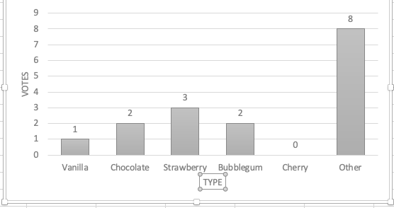

- Change the y axis title to votes
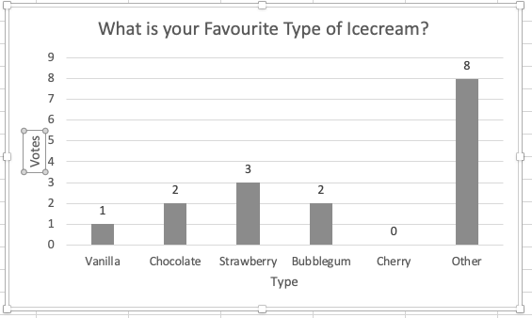

- Check scales and change if necessary.
  - Double click axis values
  - Axis options
  - Click on the icon that looks like a bar graph
  - Axis options pull down menu
  - Units
    - Major = 1
    - Minor = 0.5
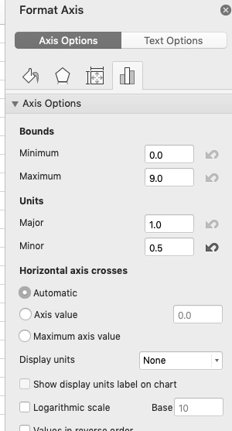
- Change colours to personalize your graph 