Student Name:
Name of Group Members:
Date:

Introduction:

In this lab, you will be examining many characteristics of a rat’s anatomy. Dissections help researchers get a 3-dimensional picture of how the systems of a body work together. Now you’ll have the opportunity to see how the respiratory, digestive and circulatory system are arranged spatially.

The Classification of the Rat (Rattus norvegicus):

Kingdom: Animalia
Phylum: Chordata
Subphylum: Vertebrata
Class: Mammalia
Order: Rodentia
Family: Muridae
Genus: Rattus
Species: Norvegicus
Note:
Dissection does not mean “to cut up.” Rather, it means “to expose for viewing.” Therefore, please follow the instructions outlined in this lab for proper dissection technique and never cut more than is absolutely necessary to expose an organ. Raise structures that you wish to cut with forceps so that you can see what lies underneath. Approach the dissection in a step-like manner. Do not discard any organs until all sections are completed.

Materials:

- Preserved Rat
- Dissecting pan
- Scissors
- Scalpel
- Forceps
- Probe
- Twine

Instructions:
Part One: External Anatomy
1. Obtain your rat and observe the general characteristics. Key terms are underlined.

The rat’s body is divided into six anatomical regions:
- Cranial region – head
- Cervical region – neck
- Pectoral region – area where front legs attach
- Thoracic region – chest area
- Abdomen – belly
- Pelvic region – area where the back legs attach

2. Note the hairy coat that covers the rat and the sensory hairs (whiskers) located on the rat’s face, called vibrissae.

3. The mouth has a large cleft in the upper lip which exposes large front incisors. Rats are gnawing mammals, and these incisors will continue to grow for as long as the rat lives.

4. Note the eyes with the large pupil and the nictitating membrane found at the inside corner of the eye. This membrane can be drawn across the eye for protection. The eyelids are similar to those found in humans.

5. The ears are composed of the external part, called the pinna, and the auditory meatus, the ear canal.

6. Locate the teats on the ventral surface of the rat. Check a rat of another sex and determine whether both sexes have teats.

7. Examine the tail. The tails of rats do not have hair. Other rodents, like gerbils, do.

8. Locate the anus, which is ventral to the base of the tail.

9. Determine whether your rat is male or female by looking near the tail for the male or female genital organs.

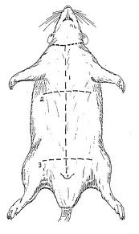
Part Two: Respiratory System
The respiratory is responsible for the exchange of gases. The rat must take in oxygen for respiration processes and must rid itself of carbon dioxide waste.

1. You will carefully remove the skin and muscles of the rat to expose the organs beneath.
Use scissors to cut through the abdominal wall of the rat following the incision marks as shown in Figure 1.

2. Cut slowly and carefully; do not cut too deeply to prevent damaging the underlying structures. Keep the tip of your dissection tool pointed upwards.
Figure 1
Note: when you cut through the thoracic cavity, you will encounter bone.

3. Once the incisions have been made, pin both skin flaps to the side of the rat.

4. Locate the trachea. The trachea is a tube that extends from the neck to the chest. It is white and lined with cartilage. The opening of the trachea is the glottis. The enlargement at the anterior end of the trachea is the larynx (voice box) which contains the vocal chords.

5. The trachea splits in the chest cavity into two bronchi. Each of these air tubes extends into the lungs and splits into smaller tubes called bronchioles. Using this information, locate the two lungs which lie on either side of the heart.

6. Locate the thin muscular diaphragm just above the liver. This muscle is responsible for drawing air into the chest cavity.

Part Three: Digestive System

1. Locate the large, reddish-brown organ called the liver which occupies much of the abdominal space. It is just under the diaphragm. The liver has many functions, one of which is to produce bile which aids in the digestion of fats. The liver also stores glycogen and transforms wastes into less harmful substances. Rats do not have a gall bladder (which is used for bile storing in other animals).
Note: You may choose to use Figure 2 to help identify the organs that make up the digestive system.

2. Locate the esophagus which runs through the diaphragm and moves food from the mouth to the stomach. It is distinguished from the trachea by its lack of cartilage rings.

3. Locate the stomach on the right side just under the liver. The function of the stomach includes food storage, physical breakdown of food, and the digestion of protein. The opening between the esophagus and the stomach is called the cardiac sphincter. The outer margin of the curved stomach is called the greater curvature; the inner margin is called the lesser curvature.

4. Locate the spleen which is about the same colour as the liver and is attached to the greater curvature of the stomach. It is shaped like a banana and is associated with the circulatory system and functions in the destruction of blood cells and blood storage. It helps with the function of the immune system. A person may live without a spleen but are more likely to get sick.

5. Locate the pancreas which is a thin membrane that may be white and granular. It lies beneath the stomach. The pancreas produces digestive enzymes that are sent to the intestine via the pancreatic duct.
6. Locate the small intestine which is a slender coiled tube that receives partially digested food from the stomach via the pyloric sphincter. The term “small” refers to its diameter, not its length. It consists of three sections: duodenum, ileum, and jejunum. The small intestine leads to the cecum (also spelled caecum, latin term for “blind”). Observe that the small intestine is not loose in the abdominal cavity but is held in place by the mesentery. Check and look for veins and arteries in the clear mesentery; they transport nutrients.

7. Locate the cecum which is a pouch that connected the large and small intestine. Food is temporarily stored in the cecum while helpful bacteria digest the cellulose found in plant cells. Most herbivores have a large cecum. In humans and other omnivores, the cecum is smaller and referred to as the appendix.

8. Locate the large intestine which is the large, possibly greenish tube that extends from the small intestine and leads to the anus. The final stage of digestion and water absorption occurs in the colon and contains a variety of bacteria to aid in digestion.
Figure 2: Digestive System
9. Locate the rectum which is the short, terminal section of the colon between the descending colon and anus. The rectum temporarily stores feces before they are expelled from the body.
Part Four: Circulatory System
The general structure of the circulatory system of the rat is almost identical to that of humans. Pulmonary circulation carries blood through the lungs for oxygenation and then back to the heart. Systematic circulation moves oxygenated blood through the body after it has left the heart

1. Observe the interior of the rat for any veins and arteries. Veins carry used blood (blue) back to the heart and lungs. Arteries carry oxygenated blood to the muscles and organs that need it. The arteries in your rat should be stained red for easy identification. Use Figures 3 and 4 to help you locate the major veins and arteries.
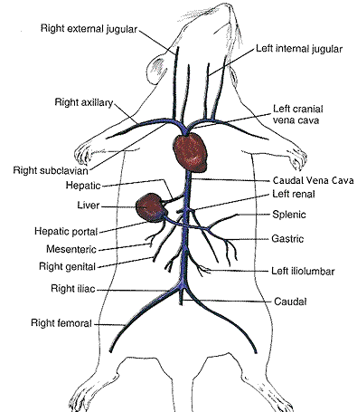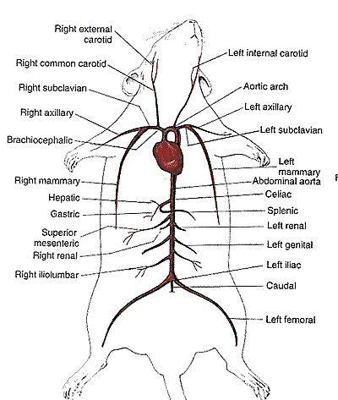
Figure 3: Circulatory System - Veins Figure 4: Circulatory System - Arteries

2. Locate the heart which is covered in a thin, tough membrane called the pericardium.
3. Proceed slowly and cautiously with this next step. Remove the heart from the pericardial sac. You will need to sever the arteries and veins connecting the heart to the circulatory system. Leave as many of the veins and arteries attached to the heart as possible.

4. Identify the aorta, the superior vena cava and pulmonary artery.

5. Cut the heart in half through the frontal plane using a sharp blade. The heart is composed of four chambers. Use Figure 5 to help you locate the 2 atria and 2 ventricles. You may also notice the septum. It is the structure that separates the two ventricles.
Figure 5: Cross Section of a Heart

Part Five: Urogenital System
This section is a study of the urogenital system. “Uro” stand for the urinary system; “genital” stands for the reproductive system. The urinary/excretory system and genital system are structurally related.

1. Locate the kidneys which are the primary organs of the excretory system. These organs are large bean shaped structures located towards the back of the abdominal cavity on either side of the spine.

2. Remove one of the kidneys and cut it lengthwise. Notice the very fine veins and arteries within. Locate the cortex and medulla on one half of the kidneys.

3. Locate the adrenal glands which are the small yellow glands embedded in the fat on top of the kidneys. They secrete adrenaline into the blood during times of stress (ie. fight or flight)

4. For male rats:
a) The major reproductive organs of the male rat are the testes (singular: testis) which are located in the scrotal sac. Cut through the sac carefully to reveal the testis. On the surface of the testis is a coiled tube called the epididymis which collects and stores sperm cells. The tubular vas deferens moves sperm from the epididymis to the urethra, which carries sperm through the penis and out the body.
b) The lumpy brown glands located to the left and right of the urinary bladder are the seminal vesicles. The gland below the bladder is the prostate gland and it is partially wrapped around the penis. The seminal vesicles and the prostate gland secrete materials that form the seminal fluid (semen).
For female rats:
a) The short gray tube lying dorsal to the urinary bladder is the vagina. The vagina divides into two uterine horns that extend toward the kidneys. This duplex uterus is common in some animals and will accommodate multiple embryos (a litter). In contrast, a uterus found in humans has a single chamber for the development of a single embryo.
b) At the tops of the uterine horns are small lumpy glands called ovaries, which are connected to the uterine horns via oviducts. The oviducts are extremely tiny and may be difficult to find without a dissecting scope.
*NOTE: You are responsible for know the individual components of both the male and female reproductive systems. Be sure to observe a rat which is the opposite sex of yours!!!

Figure 6: Male Rat (left) and Female Rat (right) Reproductive Organs
Part Six: Additional Observations

Before moving on to part seven, please read the accompanying worksheet and lab-write up directions. You may have to make additional observations so that you are able to write your lab report.

Part Seven: Clean-up

1. With soap, wash all the utensils you used except for the scalpel. The instructor will collect all blades at the end of the dissection.

2. Wash and thoroughly rinse the dissecting pan.

3. Dispose of the rat according to your instructor’s directions.

4. Return all materials to their appropriate bin.

5. Clear and wipe down your workspace.

Part Eight: Final Notes

- You must complete the ticket out the door by the end of this lab.

- You have a lab report to complete for this dissection.

PRE-LAB
Student Name:
Date:

In this lab you will have to find and identify the structures from the following systems in a rat.
Write a brief description of the structure and the function that it has.

Digestive System
Liver
Stomach
Intestines
Colon
Esophagus
Pancreas
Cecum
Circulatory System
Diaphragm
Heart
Lungs
Trachea
General Terminology
Anterior
Posterior
Ventral
Dorsal

TICKET OUT THE DOOR Student Name:

PART ONE:
These are the structures that you are expected to identify.
Check each box as you identify the corresponding organ/structure:

Respiratory System

- Trachea
- Lungs
- Diaphragm
- Bronchi

Digestive System

- Liver
- Esophagus
- Stomach
- Pancreas
- Small Intestine
- Large Intestine
- Rectum
- Spleen
- Cecum

Circulatory System

- Heart
- Superior Vena Cava
- Pulmonary Artery
- Aorta/Aortic Arch
- Right/left Atrium
- Right/left Ventricle

Excretory/Reproductive System
- Kidneys
- Adrenal Glands
- Ovaries (female only)
- Testes (male only)

PART TWO: CHECK LIST
Check all that apply:
- I have all six pages of the dissection lab.
- I have my own copy of the lab’s follow up questions.
- I understand that the follow questions are due ___________ (DD/MM/YYYY).
- I have disposed of the rat appropriately.
- My lab bench has been wiped and cleaned.
LAB REPORT Name:

1. What is the purpose of the lab?
____________________________________________________________________________________
____________________________________________________________________________________
____________________________________________________________________________________
2. What is the largest organ in the rat’s anatomy? Why?
____________________________________________________________________________________
____________________________________________________________________________________
____________________________________________________________________________________
3. Why is the gallbladder absent in rats?
____________________________________________________________________________________
____________________________________________________________________________________
____________________________________________________________________________________

4. Describe in detail the way in which blood travels in the mammalian circulatory system.
____________________________________________________________________________________
____________________________________________________________________________________
____________________________________________________________________________________
____________________________________________________________________________________
____________________________________________________________________________________
____________________________________________________________________________________
____________________________________________________________________________________
____________________________________________________________________________________

5. Describe three adaptive advantages of the mammalian anatomy.
a. ____________________________________________________________________________
____________________________________________________________________________
b. ____________________________________________________________________________
____________________________________________________________________________
c. ____________________________________________________________________________
____________________________________________________________________________

6. Describe 3 ways in which the organs of the circulatory system and respiratory system are protected.
1. ____________________________________________________________________________
____________________________________________________________________________
2. ____________________________________________________________________________
____________________________________________________________________________
3. ____________________________________________________________________________
____________________________________________________________________________
7. Draw a neatly labeled diagram of your dissected rat’s internal organs.
Include the respiratory, circulatory and digestive system (do not include the urogenital system).
The organs you are to include are the ones written on the ticket out the door.
Marks will be deducted for messy and inaccurate work.

