A&W Math 11
Course Outline
Teacher: Bandali email: abandali@sd59.bc.ca
Room: _______ Phone: 250-782-5585
Text: None (worksheets)
Welcome to A&W Math 11! Over the next 5 months, we will explore a variety of aspects of Math and the applications of math in real-life.
By the end of this course, you will have developed an important foundation of skills, attitudes, knowledge and respect towards the field of math.
Class Expectations:
Attendance→ Regular attendance is key to success in A&W Math 11. If, for whatever reason you are away, YOU are responsible to get any notes, handouts, and/or information from your contact person, the front folder box, or from the website.
Homework & Assignments→ Although time will be given to complete most assignments in class; some assignments will require time out of the class to finish. When homework is assigned, it is due the next day at the beginning of the class. All work to be handed in must be clearly labeled with name, date, and assignment information.
Safety→ As with any lab-based course, safety is of the utmost importance. Every student is responsible for his/her own safety and the safety of all others in the class. Unsafe behavior during lab time will result in an immediate zero for that lab, referral to the office and a tedious safety assignment to be completed before re-entry to the lab is permitted.
Required Materials: Have these with you every day.
- Binder with loose-leaf paper  - Duo-tang  - Graph paper | - Pens of various colors  - Pencils  - Ruler  - Eraser | - Scientific Calculator  - Well rested and inquisitive mind

Quizzes & Tests
Quizzes and tests will be taken at regular intervals throughout the course. Please be on time as extra time will not be given. Please have all necessary material with you when you are scheduled to write the quiz/test.
Math can be a very rewarding course if you engage in it. You need to be an active member of class, involve yourself in discussions, ask questions to clarify, and extend your learning.
I am available before school from approximately 8:20 - 8:40, most lunch hours and sometimes after school for extra help.

Topics:*  - financial literacy: personal investments, loans, and budgeting  - rate of change  - how probability and statistics are used in different contexts  - interpreting graphs in society  - 3D objects: angles, views, and scale diagrams  *Important Notes:  - The topics will be covered in various degrees of detail over the course  - The topics may not be covered in the order listed above. | Big Ideas:  Note: these times are approximate and subject to change.  Note: these times are approximate and subject to change.  - Proportional reasoning is used to make sense of multiplicative relationships.  - Mathematics informs financial decision making.  - 3D objects are often represented and described in 2D space.  - Flexibility with numbers builds meaning, understanding,  and confidence.  - Representing and analyzing data allows us to notice and wonder about relationships
Course Evaluation:
Labs | 35 %
Assignments | 35%
Quizzes | 15 %
Final Project | 15 %
Total | 100%

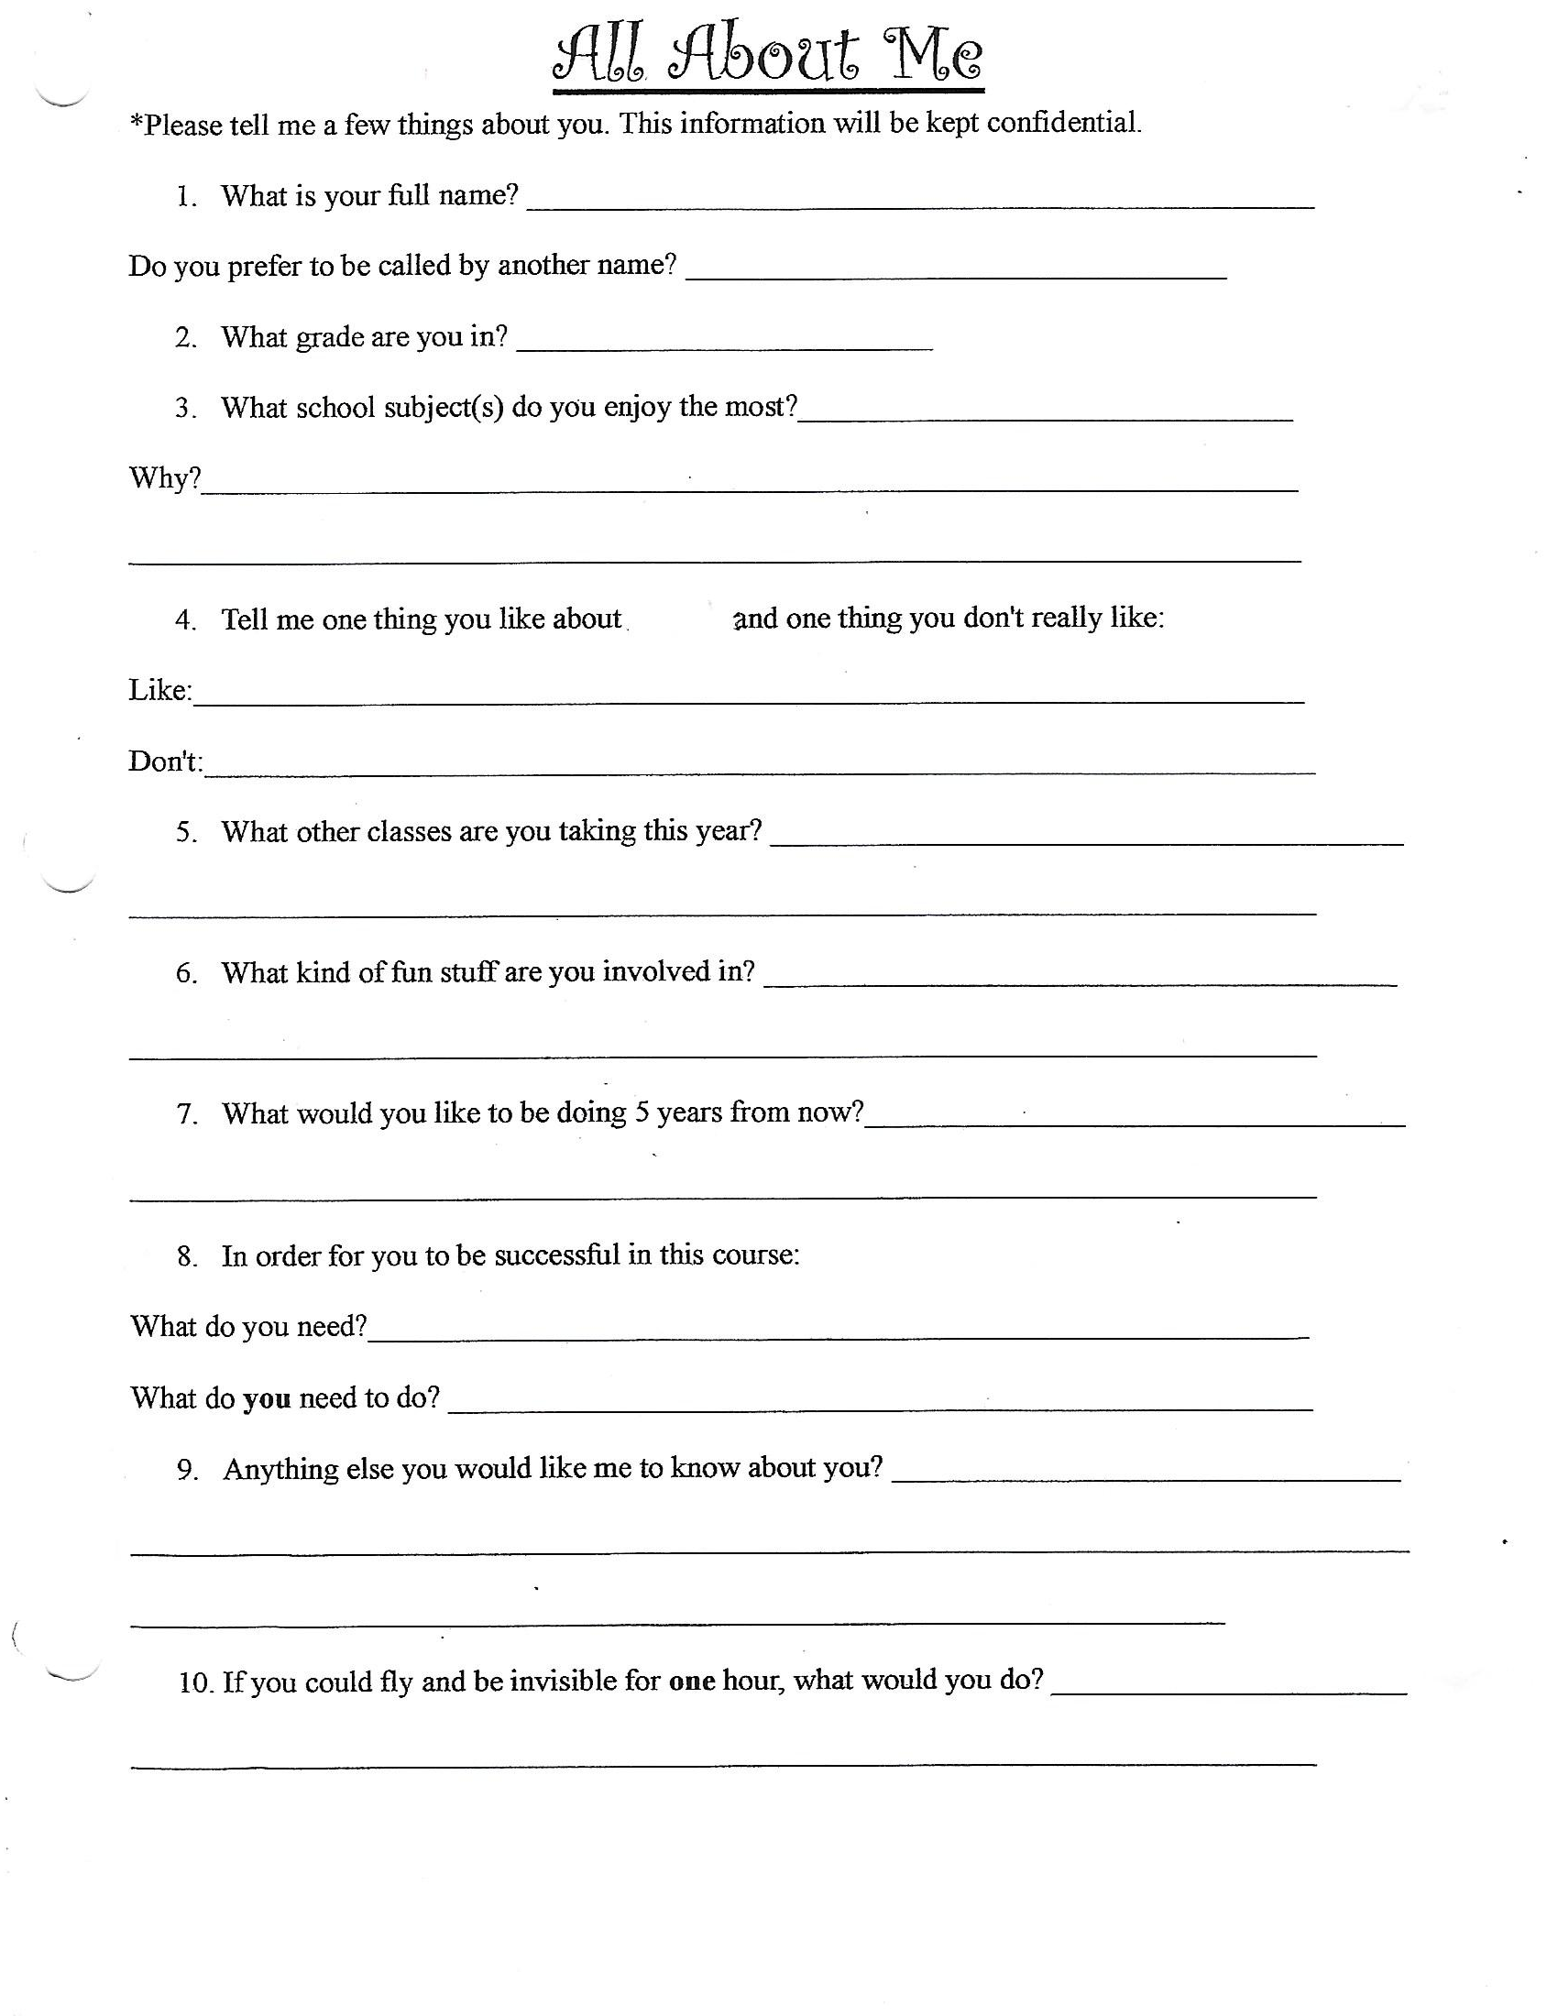
math
Welcome to __________________________________________________________ class, I am Bandali.
Parents/Guardians, in order to keep in touch with you, please fill out this contact form (please print) and have it returned to me by the end of the first week of school. Feel free to contact me at lunch, before, or after school at 250-782-5585 or by email at abandali@sd59.bc.ca

Student name:________________________________________________________________________________
Parent/Guardian name(s):__________________________________________________________________
Parent/Guardian phone #:__________________________________________________________________
Parent/Guardian email:_____________________________________________________________________

