Hours of Bright Sunshine Per Month (30 Year Average)
 | Jan | Feb | Mar | Apr | May | June | July | Aug | Sept | Oct | Nov | Dec
Hrs | 75.9 | 112.9 | 168 | 235.5 | 280 | 296 | 310 | 273.5 | 170 | 144.5 | 85 | 62
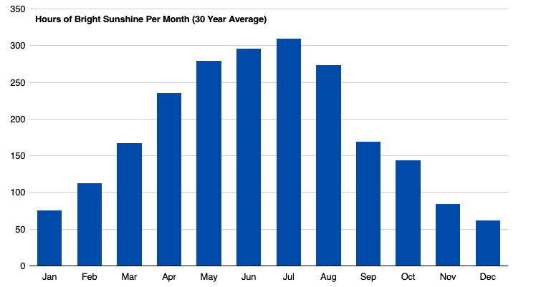

- What month has the least amount of sunshine?

- Which months have greater than (>) 270 hours of sunshine?

- Does your answer for #2 seem reasonable? Explain.

Source: https://www.dawsoncreek.ca/business-community-profile/community-profile-climate/

