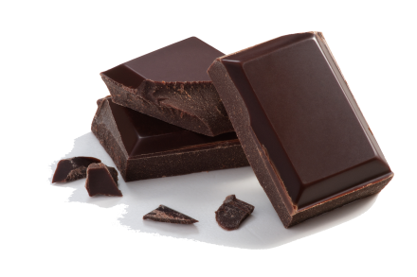
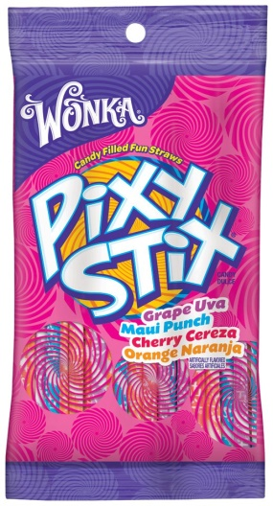
Acids and Bases

Candy Lab
Materials:
- Warheads (2 per pair)
- Dark Chocolate (2 squares per pair)
- Pixie Stix (1 per pair)
- 50 mL Beaker
- pH Paper
- Glass stirring rod
- 25 mL graduated cylinder

Procedure:
- Take a sour patch candy and taste it.
- Write down your observations
  - What did it taste like?
  - Based on the taste what type of chemical do you think it is (use Table 1 for guidance)
- Take a square of chocolate and taste it.
- Write down your observations
  - What did it taste like?
  - Based on the taste what type of chemical do you think it is (use Table 1 for guidance)
- Obtain a 50 mL beaker and put 25 mL of water into it
- Now dissolve one of the Pixy Stix in it and stir with a glass stirring rod.
- Test the solution using pH paper – DO NOT DRINK IT – dip the pH paper into the solution
- What pH does the Pixy Stix have?
- What type of chemical is this?

Table 1: Properties of Acids and Bases
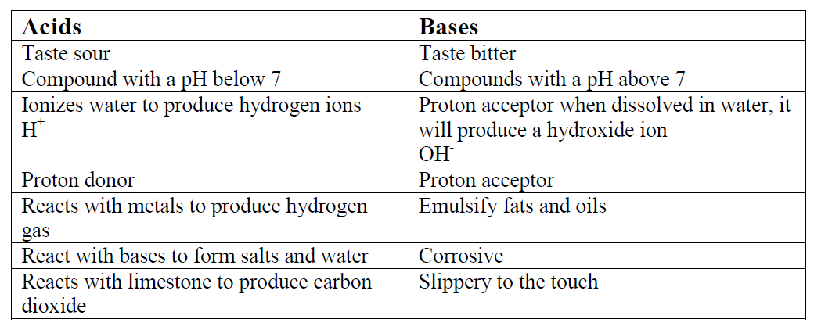

Application Questions:
- Why are acidic candies problematic to human teeth?
- What can we do to protect our teeth from acid?

