Science 10 Safety Poster

Look at the safety section of your textbook (page xiv-xvii)

For the Safety Symbols do the following (3 marks total)
- Choose 1 safety symbol (1 mark).
- For the safety symbol chosen, provide a rationale for why this rule is necessary in the science lab – write this on a piece of paper to include with your poster (1 mark).
- Draw your own symbol and include it on your poster along with the symbol’s meaning and rationale as to why it is necessary in the science lab (1 mark).

For the WHMIS Symbols do the following (3 marks total)
- Choose 1 WHMIS symbol (1 mark).
- For the WHMIS symbol chosen, provide a rationale for why this rule is necessary in the science lab – write this on a piece of paper to include with your poster (1 mark).
- Draw your own symbol and include it on your poster along with the symbol’s meaning and rationale as to why it is necessary in the science lab (1 mark).

For the Safety Rules and Procedures do the following (3 marks total)
- Choose 1 Safety Rule and Procedure (1 mark)
- For the Safety Rule and Procedure chosen you need to provide a rationale for why this safety rule and procedure is necessary in the science lab – write this on a piece of paper to include with your poster (1 mark).
- Draw your own symbol or write a paragraph for the safety rule and procedure chosen and include it on your poster along with a rationale as to why this is necessary in the science lab (1 mark).

Total Mark for the Poster and Assignment: _______________/19 Marks

Make sure to look at the rubric on the back of the page
Additionally, your poster will be marked using the rubric below:
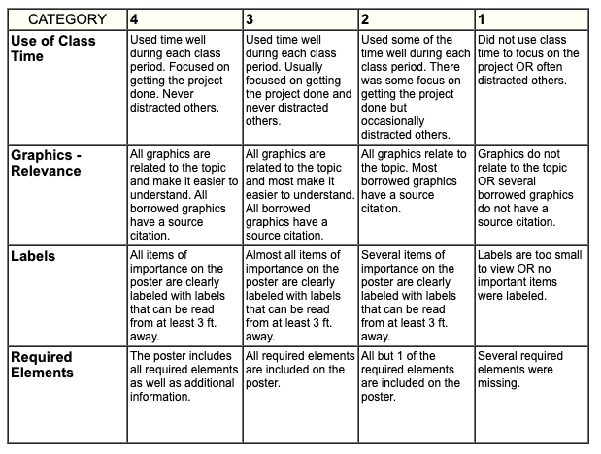
/2
/2
/4
/2

