Final Project:

Step 1:
Need to ask a question related to the course/class

Step 2: Need to describe how you will research your project. Also, need to include some type of experiment you can conduct to test your question (not all topics will have an experiment you can conduct, but you still have to pose an experiment that could be done to support your question).

Step 3: Research your question.

Step 4: conduct/describe your experiment (include all the steps that would need to be taken to repeat this experiment)

Step 5: Come up with a conclusion.

Step 6: Create a product to display your results and discuss your result.

Step 7: Reflect on what you have learned as well as how you can improve/change your process.

NOTES:
- This project is out of 40 MARKS
- You must reference any resources you used (videos, books, images, website, etc.)
- Spelling and grammar count.
- Creativity, colour, neatness and originality can earn you 2 bonus marks (0.5 marks for each one).
- Do not rush this project as it is a process and need careful reflection and consideration.
- The Inquiry Process image attached needs to be completed (that is you need to be able to answer all the question asked).
- There is a rubric attached that you need to follow in order to be successful.

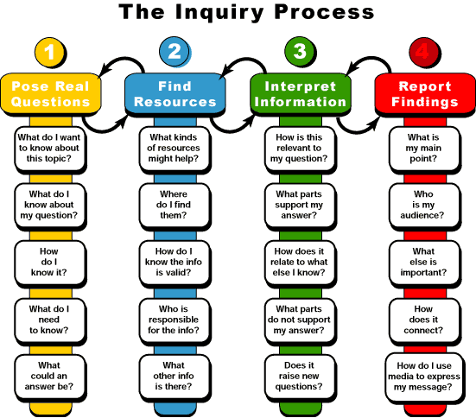
Categories | Excellent – 4 | Good – 3 | Fair – 2 | Poor – 1 | Scale | Mark
Preparation & Deadlines | - Inquiry Question Draft – on time  - Written draft handed in – on time  - Final product (poster, PPT, 3D model, etc.) – handed in – on time  - Bibliography completed – on time | - Inquiry Question Draft – 1 day late  - Written draft handed in – 1 day late  - Final product (poster, PPT, 3D model, etc.) – handed in – 1 day late  - Bibliography completed – 1 day late | - Inquiry Question Draft – > 2 day late  - Written draft handed in – > 2 day late  - Final product (poster, PPT, 3D model, etc.) – handed in – > 2 day late  - Bibliography completed – > 2 day late | - Inquiry Question Draft – not handed in  - Written draft handed in – not handed in  - Final product (poster, PPT, 3D model, etc.) – handed in – > 2 day late  - Bibliography completed – > 2 day late | ____ x 1 | /4
Content | - Information directly answers the inquiry question  - Stays on topic  - Very detailed, descriptive  - Excellent planning, easy to follow  - Propper grammar, punctuation and spelling | - Information does not directly answer the inquiry question  - Stays on topic most of the time  - Could use more details, description  - Good planning, easy to follow  - A few grammar, punctuation and spelling mistakes (4 or 5) | - Information vaguely answers the inquiry question  - Strays from the topic  - Not very detailed or descriptive  - Not well planned out, hard to follow  - Many grammar, punctuation, and spelling mistakes (6 to 10) | - Information is not related to the inquiry question  - Does not say on topic  - Very little details  - Little planning  - Multiple grammar, punctuation and spelling misstates (more than 10) – hard to read | ____ x 2 | /8
Research | - 5 or more references including a book  - Proper format for bibliography  - Written entirely in own words | - 3 references including a book  - Most of bibliography in proper format  - Written mostly in own words | - 3 references  - Bibliography not in the proper format  - Not in own words – copied sections | - 1 reference  - Bibliography not done well  - Entirely copied – not in own words | ____ x 2 | /8

Categories | Excellent – 4 | Good – 3 | Fair – 2 | Poor – 1 | Scale | Mark
Final Product (poster, PPT, 3D model, etc.). | - Inquiry question clearly visible  - Very well planned out has a theme  - Colorful, vibrant and eye catching  - Pictures are relevant to the topic  - Includes at least 3 pictures | - Inquiry question not clearly displayed  - Some planning for the layout  - Colorful display  - Pictures are somewhat relevant to the topic  - Includes 2 pictures | - Inquiry question too similar to title  - Does not appear to be planned out  - Display needs more colour  - Pictures are somewhat relevant to the topic  - Includes 1 picture | - No inquiry question  - No apparent plan  - Haphazardly created  - Lacks color  - No pictures  - No titles | ____ x 3 | /12
Reflection | - Detailed, thoughtful reflection on how the project answers the inquiry question  - Detailed, thoughtful reflection on the research process  - Detailed, thoughtful reflection on ways to improve | - Reflection on how the project answers the inquiry question  - Reflection on the research process  - Reflection on ways to improve | - Reflection on how the project answers the inquiry question could include more details  - Reflection on the research process could include more details  - Reflection on ways to improve could include more details | - Reflection on how the project answers the inquiry question was incomplete or not answered  - Reflection on the research process was incomplete or not answered  - Reflection on ways to improve was incomplete or not answered | ____ x 2 | /8
 |  |  |  |  | Total Mark | /40

